**Ideation Phase**

**Empathize & Discover**

|  |  |
| --- | --- |
| Date | 31 January 2025 |
| Team ID | LTVIP2025TMID32163 |
| Project Name | Smart SDLC – AI Enhanced Software Development Lifecycle |
| Maximum Marks | 4 Marks |

### ****Empathy Map Canvas: Smart SDLC****

An **empathy map** is a powerful, visual tool that captures what developers and learners **think**, **feel**, **say**, and **do** during the software development process. It helps your team gain a deeper understanding of user motivations, frustrations, and needs—so you can build solutions that resonate.

Smart SDLC is a generative AI-powered application built using **FastAPI** and **IBM's Granite-3.3-2b-instruct model**, offering real-time, phase-wise assistance across the Software Development Life Cycle (SDLC). It’s designed to support developers, learners, and teams by delivering intelligent automation and contextual guidance at every stage of development.

Creating an empathy map for Smart SDLC helps your team walk in the users’ shoes, enabling you to design features and support that solve real-world software development pain points.

**Example:**

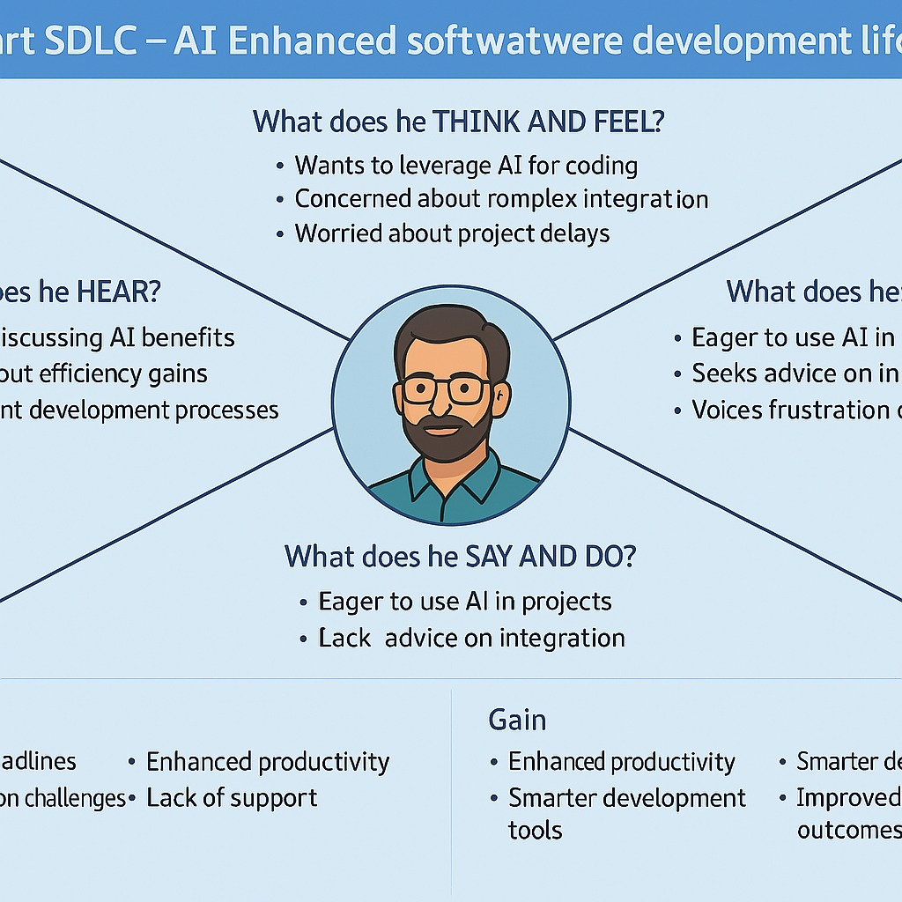

Reference: <https://www.mural.co/templates/empathy-map-canvas>

**Example: Food Ordering & Delivery Application**

